**<<Project name>>**

**Software Requirement Specification**

– HCM, Mar 2023 –

**Table of Contents**

I. Overview 3

1. Introduction 3

2. System Functions 4

3. Common Requirements 5

II. Functional Requirements 6

1. <<Feature Name 1>> 6

a. <<Function Name 1>> 6

b. <<Function Name 2>> 6

2. <<Feature Name 2>> 6

# I. Overview

## 1. Introduction

My project is about the milk tea trading website. Web em includes user login functions to buy and sell products and update product prices, remove products when not in use.

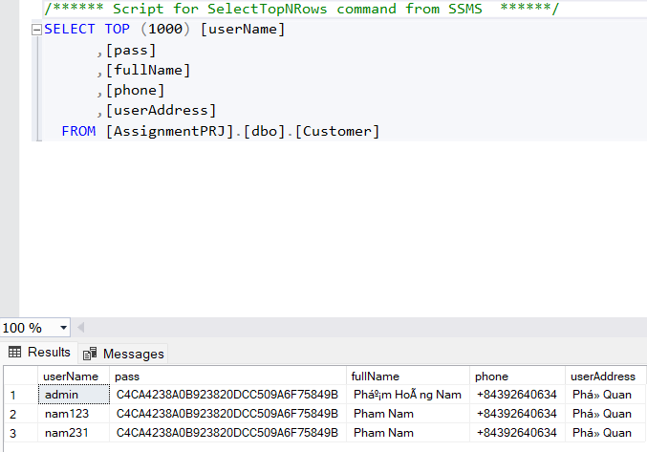

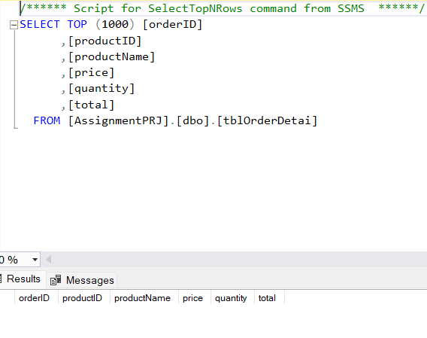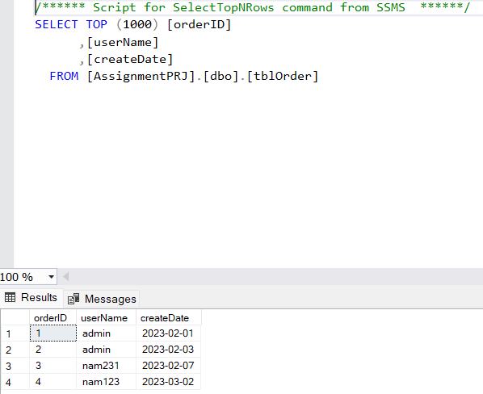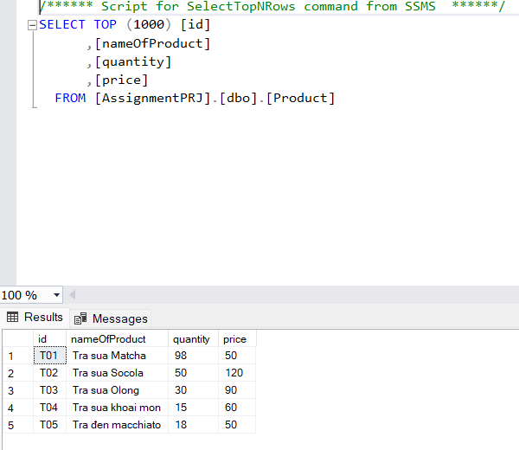>>

## 2. System Functions

#### a. Screen Flow

*[This part shows the system screens and the relationship among screens. You can draw the Screens Flow for the system in the form of diagram as below]*

#### b. Screen Details

*[Provide the descriptions for the screens in the Screens Flow above]*

***b.1 User Wed Application***

|  |  |  |  |
| --- | --- | --- | --- |
| **#** | **Feature** | **Screen** | **Description** |
| 1 | View Landing Page about | Landing Page | Contains an introduction about “Rạp xiếc trung ương” and the main features of the application. |
| 2 | Get list of milk tea | Home Page | List of milk tea |
| 4 | Get milk tea detail | View Cart | Contains milk tea details about milk tea information, quantities textbox, add to cart button |
| 5 | Login account | Login page | Contains text box to input username and password, login button, register link, login with Gmail button, rem |
| 6 | Register account | Register page | Contains text box to input user information, register button |
| 7 | Check out | Check out page | Click button check out |
| 9 | Buy milk tea | Confirm milk tea | Contains user’s information, quantities , price, check out button. |

* …

# II. Functional Requirements

## 1. Login

* Function trigger: after clicking login button or click the button to milk tea without logging in
* Function description: The system allows users to use their username and password to log in to the system as customer
* Screen layout:

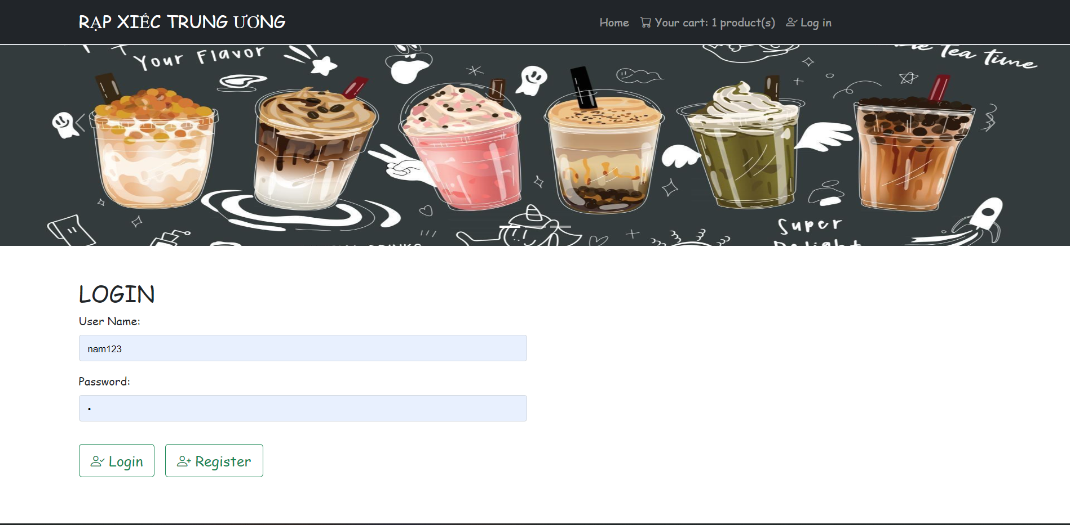

## 2. Register

* Function trigger: after clicking register button
* Function description: The system allows users to register for an account
* Screen layout: 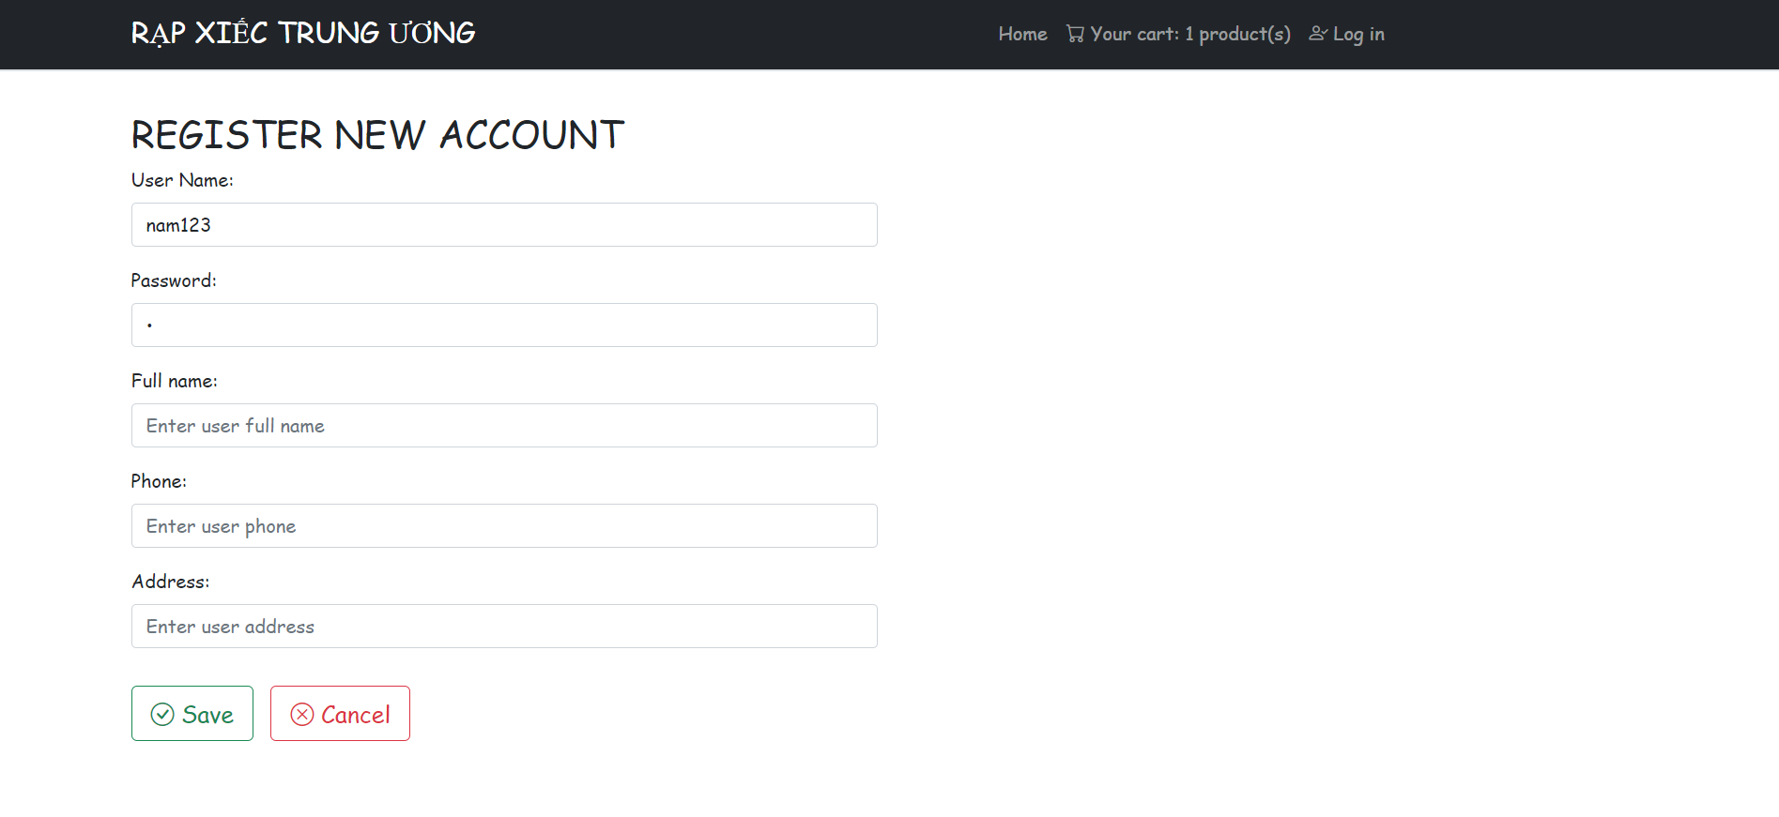

## 3. Show homepage

* Function trigger: after the clicking “Home” link or homepage tab
* Function description: the system shows the homepage for user
* Screen layout:

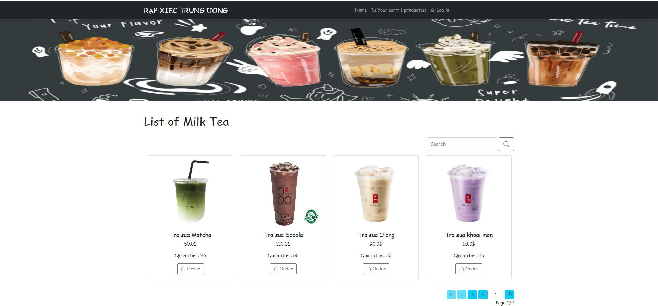

## 4. Search Milk Tea by name

* Function trigger: after choose Name milk te clicking search button
* Function description: Display milk tea according to user’s search request
* Screen Layout:

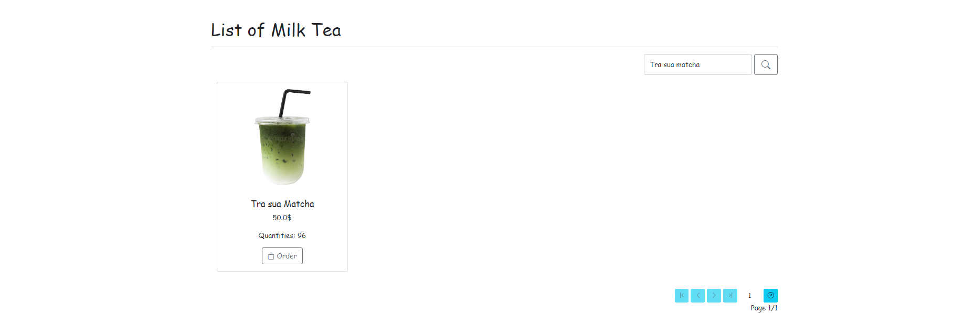

## 5. Show list of milk tea

* Function trigger: at home page
* Function description: at home page,
* Screen layout:

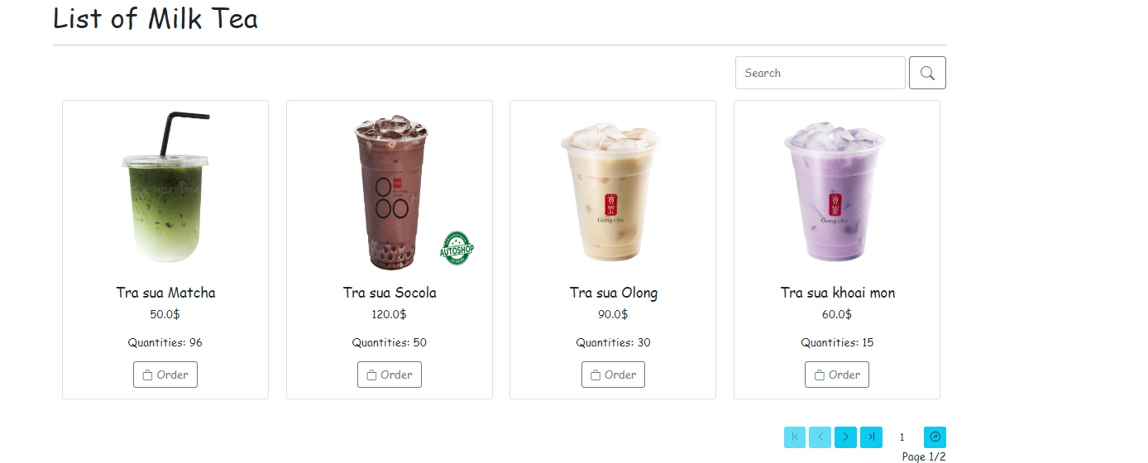

## 6. Show the quantity and product user want order

* Screen layout: 

## 7. Confirm Order

* Function trigger: after choosing item slot of milk tea
* Function description: display user’s information, quantites, price
* Screen layout: 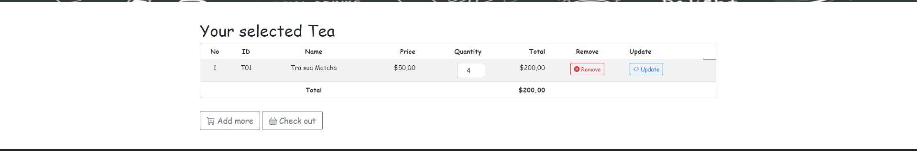

## 8. Notice of successful order

* Function trigger: after clicking Check out
* Function description: if user don’t have account message is displayed on the confirm Check out. Return login page to login account
* Screen layout:

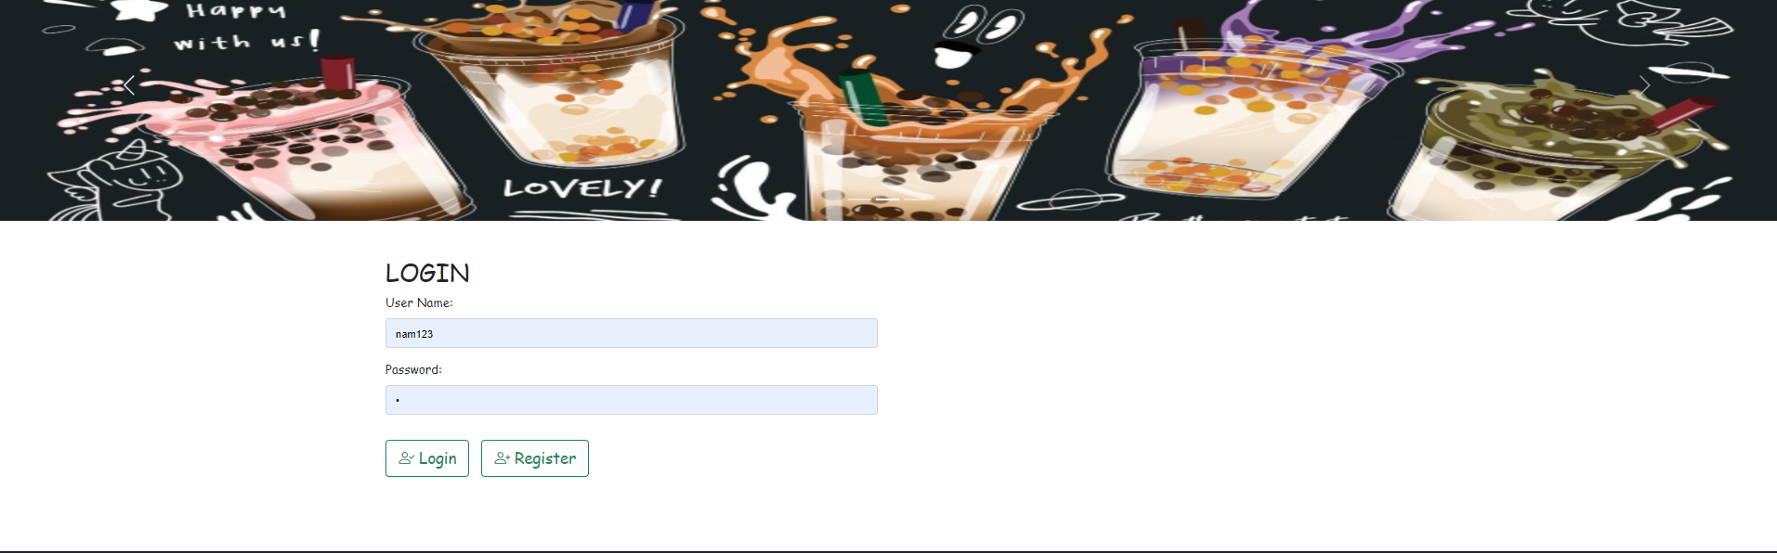

## 9 Notice of successful order

* Function trigger: after clicking Check out
* Function description: a success message is displayed on the confirm Check out
* Screen layout:

